# **Name: Abdurrahman Qureshi**

# **Roll No: 210451**

Practical No: 9

**1) Write a Program to create 2 toggle buttons and on the click of the button it should display which button is pressed.**

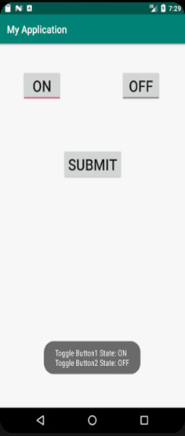

**XML CODE:**

<?xml version="1.0" encoding="utf-8"?>  
<RelativeLayout xmlns:android="http://schemas.android.com/apk/res/android"  
 xmlns:app="http://schemas.android.com/apk/res-auto"  
 xmlns:tools="http://schemas.android.com/tools"  
 android:layout_width="match_parent"  
 android:layout_height="match_parent"  
 android:padding="10dp"  
 tools:context=".MainActivity">  
  
 <ToggleButton  
 android:layout_width="wrap_content"  
 android:layout_height="wrap_content"  
 android:layout_centerHorizontal="true"  
 android:layout_marginTop="200dp"  
 android:id="@+id/toggleButton1"/>  
  
 <ToggleButton  
 android:layout_width="wrap_content"  
 android:layout_height="wrap_content"  
 android:layout_centerHorizontal="true"  
 android:layout_below="@id/toggleButton1"  
 android:id="@+id/toggleButton2"/>  
  
 <Button  
 android:layout_width="wrap_content"  
 android:layout_height="wrap_content"  
 android:text="SUBMIT"  
 android:layout_centerHorizontal="true"  
 android:layout_marginTop="50dp"  
 android:id="@+id/submitBtn"  
 android:layout_below="@id/toggleButton2"/>  
</RelativeLayout>

**JAVA CODE:**

package com.example.madprac9;  
  
import androidx.appcompat.app.AppCompatActivity;  
  
import android.os.Bundle;  
import android.view.View;  
import android.widget.Button;  
import android.widget.Toast;  
import android.widget.ToggleButton;  
  
public class MainActivity extends AppCompatActivity {  
  
 @Override  
 protected void onCreate(Bundle savedInstanceState) {  
 super.onCreate(savedInstanceState);  
 setContentView(R.layout.*activity_main*);  
  
 Button submitBtn = (Button)findViewById(R.id.*submitBtn*);  
 ToggleButton toggleButton1 = (ToggleButton)findViewById(R.id.*toggleButton1*);  
 ToggleButton toggleButton2 = (ToggleButton)findViewById(R.id.*toggleButton2*);  
  
 submitBtn.setOnClickListener(new View.OnClickListener() {  
 @Override  
 public void onClick(View view) {  
 String result = "";  
 result += "Toggle Button 1 State: " + toggleButton1.getText().toString();  
 result += "\nToggle Button 2 State: " + toggleButton2.getText().toString();  
 Toast.*makeText*(getApplicationContext(), result, Toast.*LENGTH_LONG*).show();  
 }  
 });

}}

**OUTPUT:**

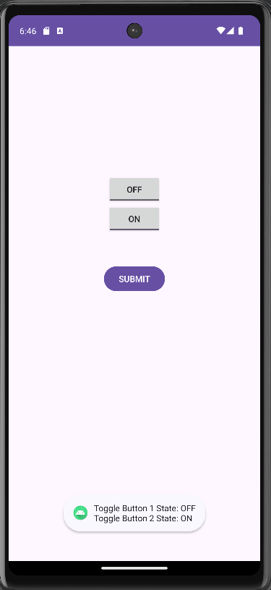

**2) Write a Program to create a toggle button to display the ON/OFF Bluetooth on the display screen.**

**XML CODE:**

<?xml version="1.0" encoding="utf-8"?>  
<LinearLayout xmlns:android="http://schemas.android.com/apk/res/android"  
 xmlns:app="http://schemas.android.com/apk/res-auto"  
 xmlns:tools="http://schemas.android.com/tools"  
 android:layout_width="match_parent"  
 android:layout_height="match_parent"  
 android:padding="10dp"  
 tools:context=".MainActivity">  
 <TextView  
 android:layout_width="wrap_content"  
 android:layout_height="wrap_content"  
 android:text="Bluetooth"  
 android:textSize="30dp"  
 android:layout_marginLeft="20dp"  
 android:layout_marginTop="30dp"/>  
 <ToggleButton  
 android:layout_width="wrap_content"  
 android:layout_height="wrap_content"  
 android:layout_marginTop="30dp"  
 android:layout_marginLeft="100dp"  
 android:id="@+id/toggleButton"/>  
</LinearLayout>

**JAVA CODE:**

package com.example.madprac9;  
import androidx.appcompat.app.AppCompatActivity;  
import android.os.Bundle;  
import android.view.View;  
import android.widget.Button;  
import android.widget.Toast;  
import android.widget.ToggleButton;  
public class MainActivity extends AppCompatActivity {  
 @Override  
 protected void onCreate(Bundle savedInstanceState) {  
 super.onCreate(savedInstanceState);  
 setContentView(R.layout.*activity_main*);  
 ToggleButton toggleButton = (ToggleButton)findViewById(R.id.*toggleButton*);  
 toggleButton.setOnClickListener(new View.OnClickListener() {  
 @Override  
 public void onClick(View view) {  
 Toast.*makeText*(getApplicationContext(), "Bluetooth turned " + toggleButton.getText().toString().toLowerCase(), Toast.*LENGTH_SHORT*).show();  
 }  
 }); }}

**OUTPUT:**

